Backlink Performance Analysis (Aug’ 26 )

Source
Semrush, GSC, Moz

URLs Tracked
15
Total pages monitored

Keywords Tracked
35
Total keywords monitored
Plan Total Backlinks (Till Aug)
420
Actual Total Backlinks (Till Aug)
381

Business Impact of Backlinks
Source: GSC
Aug’26
remote desktop - 29
remote desktop software - 31
remote access - 5
remote access software - 101
remote support - 10
remote support software - 101

teamviewer alternative - 5
teamviewer pricing - 5
logmein alternative - 18
logmein pricing - 39
anydesk alternative - 7
anydesk pricing - 4
patch management - 6
patch management software - 101
autonomous endpoint management - 5

Dec’25
remote desktop - 12
remote desktop software - 20
remote access - 7
remote access software - 13
remote support - 8
remote support software - 12
teamviewer alternative - 7
teamviewer pricing - 20
logmein alternative - 22
logmein pricing - 11
anydesk alternative - 20
anydesk pricing - 8
patch management - 62
patch management software - 101
autonomous endpoint management - 14

Add this KeyTakeaway:
Remote access and remote desktop keywords continue to deliver strong visibility, with 'remote access (5)' maintaining a top 5 position, while 'remote desktop (29)' continues to rank within the top 30.
Competitor keywords continue to strengthen, with 'anydesk pricing (4)' and 'teamviewer alternative (5)' ranking in the top 5, while 'teamviewer pricing (5)' maintains its top 5 position and 'anydesk alternative (7)' moves into the top 10.
'teamviewer pricing (5)' now ranking in the top 5, while 'teamviewer alternative (9)' maintains a first-page position.

Patch management is showing significant improvement, moving from position 62 to 8 and securing a first-page ranking.

Referring Domains DA

Here are the Referring DA categories of the given backlinks
Referring Domain DA
DA 71 - 100 - 53
DA 41-70 - 287
DA 25 -40 - 41

Monthly Backlink Growth

Backlink monthly growth trend
Feb’ 26 Mar’26 Apr’26 May’26 June’26 July’26 Aug’
Total Backlinks
50 25 48 83 32 108 35

Keyword Ranking Performance

Keywords in Top 5

Dec’25 - 0
Aug’26 - 5

Dec’25

remote access - 7
teamviewer alternative - 7
teamviewer pricing - 20
anydesk pricing - 8
autonomous endpoint management - 14

Aug’26
remote access - 5
teamviewer alternative -5
teamviewer pricing -5
anydesk pricing - 4
autonomous endpoint management—5

Keywords on First Page (Top 10)
Dec‘25 - 4
Aug’26- 8

Dec’25
remote access - 7
remote support - 8
teamviewer alternative - 7
teamviewer pricing - 20
anydesk pricing - 8
anydesk alternative - 20
patch management - 62
autonomous endpoint management - 14

Aug’26
remote access – 5
remote support – 10
teamviewer pricing – 5
teamviewer alternative – 5
anydesk pricing – 4
anydesk alternative - 7
patch management – 6
autonomous endpoint management - 5

Tracked URLs
- https://www.splashtop.com/blog/what-is-remote-desktop
- https://www.splashtop.com/solutions/remote-desktop
- https://www.splashtop.com/blog/what-is-remote-access
- https://www.splashtop.com/products/remote-access
- https://www.splashtop.com/blog/what-is-remote-support
- https://www.splashtop.com/products/remote-support
- https://www.splashtop.com/compare/teamviewer-alternative
- https://www.splashtop.com/blog/teamviewer-pricing-comparison
- https://www.splashtop.com/compare/logmein-alternative
- https://www.splashtop.com/compare/logmein-alternative/pricing
- https://www.splashtop.com/compare/anydesk-alternative
- https://www.splashtop.com/blog/anydesk-pricing-comparison
- https://www.splashtop.com/blog/what-is-patch-management
- https://www.splashtop.com/solutions/patch-management
- https://www.splashtop.com/blog/autonomous-endpoint-management-comprehensive-guide

Performance Summary

 | "Baseline  Dec'25" | FeFeb'26 | Mar'26 | Apr'26 | May’26 | June’26 | July’26 | Aug’26
Total Backlinks | - | 3 | 8 | 11 | 20 | 23 | 29 | 32
Remote Access | 7 | 6 | 7 | 5 | 6 | 4 | 5 | 5
What is remote access | 8 | 6 | 6 | 4 | 3 | 3 | 3 | 4
benefits of remote access | 2 | 3 | 2 | 2 | 3 | 3 | 3 | 3
remote desktop access | - | 20 | 18 | 11 | 21 | 10 | 8 | 9
Page Authority | 43 | 44 | 44 | 44 | 44 | 44 | 44 | 44

 | "Baseline  Dec'25" | Feb'26 Feb'26 | Mar'26 | Apr'26 | May’26 | June’26 | July,26 | Aug’26
Total Backlinks | - | 3 | 5 | 8 | 16 | 21 | 34 | 35
remote support | 8 | 12 | 13 | 22 | 14 | 10 | 6 | 10
what is remote support | 3 | 3 | 3 | 4 | 4 | 4 | 3 | 3
remote desktop support | 17 | 12 | 9 | 20 | 17 | 16 | 19 | 22
Page Authority | 33 | 38 | 38 | 40 | 42 | 42 | 42 | 42

 | "Baseline  Dec'25" | Feb'26 Feb'26 | Mar'26 | Apr'26 | May’26 | June’26 | July’26 | Aug’26
Total Backlinks | - | 12 | 15 | 29 | 43 | 47 | 61 | 69
Remote access software | 13 | 1 | 1 | 1 | 6 | 101 | 101 | -
Remote Access Solution | 4 | 1 | 1 | 1 | - | 101 | 101 | -
remote access tool | 11 | - | - | - | - | - | 101 | -
Page Authority | 43 | 46 | 46 | 47 | 47 | 47 | 47 | 48

 | "Baseline  Dec'25" | Feb'26 Feb'26 | Mar'26 | Apr'26 | May’26 | June’26 | July’26 | Aug’26
Total Backlinks | - | 14 | 23 | 27 | 38 | 41 | 59 | 62
Remote support software | 12 | 11 | 82 | 5 | 1 | - | 101 | -
Remote Support Solution | 4 | 17 | 2 | 3 | 1 | - | 101 | -
remote support tool | 9 | 7 | - | - | 1 | - | 101 | -
remote it support software | 8 | 7 | - | - | - | - | 101 | -
Page Authority | 45 | 47 | 47 | 47 | 48 | 48 | 48 | 48

 | "Baseline  Dec'25" | Feb'26 Feb'26 | Mar'26 | Apr'26 | May’26 | June’26 | July’26 | Aug’26
Total Backlinks | - | 11 | 14 | 26 | 38 | 44 | 63 | 71
Remote desktop software | 20 | 40 | 15 | 13 | 11 | 15 | 28 | 31
Remote desktop Solution | 32 | 53 | 25 | 24 | 31 | 22 | 17 | 18
remote desktop connection software | 37 | 36 | 21 | 24 | 27 | 32 | 16 | 27
remote pc software | 38 | 56 | 24 | 18 | 40 | 45 | 44 | 39
remote desktop program | 48 | 39 | 18 | 13 | 9 | 16 | 26 | 28
remote desktop tools | 26 | 35 | 11 | 6 | 25 | 17 | 11 | 10
Remote Desktop | 12 | 42 | 29 | 27 | 27 | 15 | 5 | 6
Page Authority | 45 | 45 | 45 | 46 | 46 | 46 | 46 | 46

 | "Baseline  Dec'25" | Feb'26 Feb'26 | Mar'26 | Apr'26 | May’26 | June’26 | July’26 | Aug’26
Total Backlinks | - | 5 | 8 | 11 | 18 | 22 | 32 | 36
Remote Desktop | 4 | 72 | 29 | 10 | 3 | 3 | 3 | 29
What is remote desktop | 5 | 9 | 4 | 10 | 16 | 25 | 22 | 16
Page Authority | 36 | 41 | 41 | 43 | 43 | 43 | 43 | 43

 | "Baseline  Dec'25" | Feb'26 Feb'26 | Mar'26 | Apr'26 | May’26 | June’26 | July’26 | Aug’26
Total Backlinks | - | 1 | 1 | 2 | 3 | 3 | 6 | 7
autonomous endpoint management software | 2 | 1 | 4 | 3 | 3 | - | 101 | -
Page Authority | 38 | 42 | 42 | 42 | 43 | 43 | 43 | 43

 | "Baseline  Dec'25" | Feb'26 Feb'26 | Mar'26 | Apr'26 | May,26 | June’26 | Jul’26 | Aug’26
Total Backlinks | - | - | - | - | 2 | 2 | 4 | 4
anydesk pricing | 8 | 7 | 6 | 6 | 8 | 5 | 4 | 4
Page Authority | 54 | 41 | 41 | 42 | 42 | 42 | 42 | 42

 | "Baseline  Dec'25" | Feb'26 Feb'26 | Mar'26 | Apr'26 | May’26 | June’26 | July’26 | Aug’26
Total Backlinks | - | - | - | - | 2 | 2 | 4 | 4
teamviewer pricing | 20 | 11 | 8 | 7 | 8 | 9 | 5 | 5
Page Authority | 41 | 41 | 41 | 41 | 41 | 41 | 41 | 41

 | "Baseline  Dec'25" | Feb'26 Feb'26 | Mar'26 | Apr'26 | May’26 | June’26 | July’26 | Aug’26
Total Backlinks | - | - | - | - | 2 | 2 | 4 | 4
anydesk alternative | 20 | 16 | 9 | 29 | 24 | 24 | 19 | 7
Page Authority | 40 | 40 | 40 | 40 | 40 | 40 | 40 | 40

 | "Baseline  Dec'25" | Feb'26 Feb'26 | Mar'26 | Apr'26 | May’26 | June’26 | July '26 | Aug’26
Total Backlinks | - | - | - | - | 2 | 2 | 4 | 4
logmein alternative | 22 | 21 | 7 | 13 | 22 | 21 | 17 | 18
Page Authority | 39 | 40 | 40 | 40 | 40 | 40 | 40 | 40

 | "Baseline  Dec'25" | Feb'26 Feb'26 | Mar'26 | Apr'26 | May’26 | June’26 | July’26 | Aug’26
Total Backlinks | - | - | - | - | 2 | 2 | 4 | 4
teamviewer alternative | 7 | 6 | 5 | 8 | 5 | 9 | 9 | 5
Page Authority | 43 | 43 | 43 | 43 | 43 | 43 | 43 | 43

 | "Baseline  Dec'25" | Feb'26 Feb'26 | Mar'26 | Apr'26 | May’26 | June’26 | July’26 | Aug’26
Total Backlinks | - | - | - | - | 2 | 2 | 4 | 4
logmein pricing | 11 | 14 | 18 | 32 | 31 | 35 | 32 | 39
Page Authority | 54 | 39 | 39 | 38 | 39 | 39 | 39 | 39

 | "Baseline  Dec'25" | Feb'26 Feb'26 | Mar'26 | Apr'26 | May’26 | June’26 | July’26 | Aug’26
Total Backlinks | - | - | - | 3 | 6 | 10 | 13 | 14
patch management | 62 | 34 | 20 | 16 | 12 | 9 | 8 | 6
what is patch management | 29 | 17 | 11 | 10 | 8 | 3 | 4 | 2
Page Authority | 37 | 35 | 35 | 37 | 38 | 38 | 38 | 38

 | "Baseline  Dec'25" | Feb'26 Feb'26 | Mar'26 | Apr'26 | May’26 | June’26 | July’26 | Aug’26
Total Backlinks | - | - | - | 4 | 9 | 11 | 19 | 24
patch management software | - | 50 | 35 | 39 | 39 | - | – | -
automated patch management solution | 28 | 21 | 11 | 12 | 29 | - | - | -
patch management solution | 24 | 26 | 32 | 34 | 34 | - | - | -
Page Authority | 33 | 33 | 33 | 38 | 39 | 39 | 39 | 39

 | "Baseline  Dec'25" | Feb'26 Feb'26 | Mar'26 | Apr'26 | May’26 | June’26 | July’26 | Aug’26
Total Backlinks | - | - | - | 1 | 2 | 3 | 5 | 6
autonomous endpoint management | 14 | 5 | 7 | 7 | 5 | - | 2 | 5
Page Authority | 33 | 33 | 33 | 33 | 35 | 35 | 35 | 35

Implementation Details
Detailed Monthly Backlinks Sheet -
Splashtop: Monthly Backlinks 2026

Should look like this
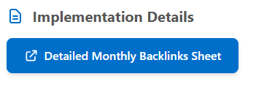

Key Findings

- Remote access and support keywords continue to maintain strong visibility, with 'remote access (5)' ranking in the top 5 and 'remote support (10)' securing a first-page position.
- Approximately 89% of referring domains have a DA between 41–100, reflecting a strong backlink profile supported by authoritative and credible websites.
- Most of the competitor keywords are showing great improvement, with three keywords now ranking in the top 10 positions.
- Domain authority improved for a key referring domain, with the DA increasing from 43 to 48 for the domain associated with 'remote access software.'

Highlights

- “Remote Access” Maintains Strong Top 5 Visibility

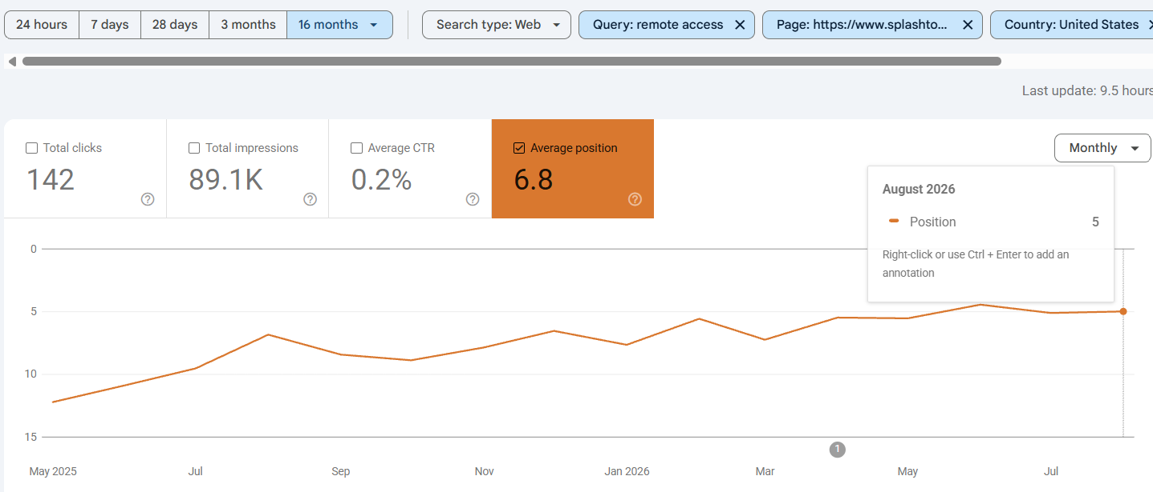

The “Remote Access” keyword continued its upward trajectory, reaching #5 in August and maintaining strong visibility for one of Splashtop’s core search categories.

- Major Ranking Breakthrough for “Patch Management”

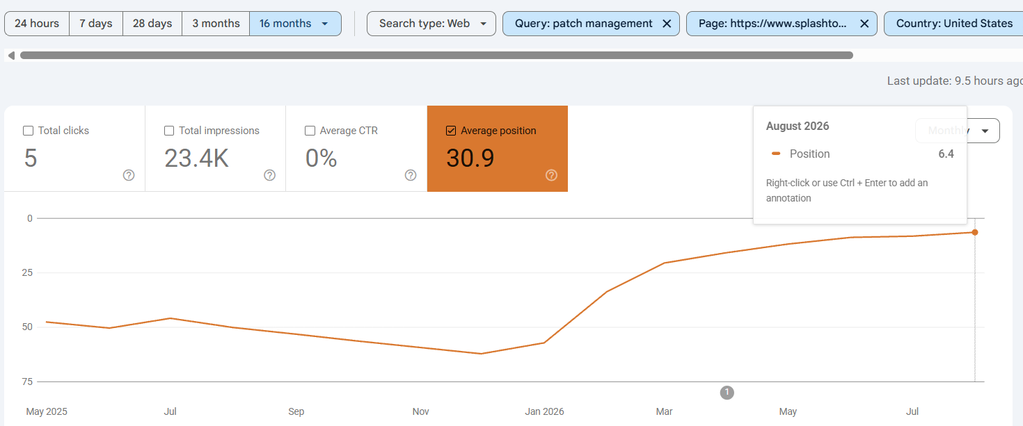
The “Patch Management” keyword made a substantial jump from the 40s into the Top 10, reaching #6 in August and significantly expanding visibility for this priority category.

- “TeamViewer Pricing” Strengthens Competitive Visibility

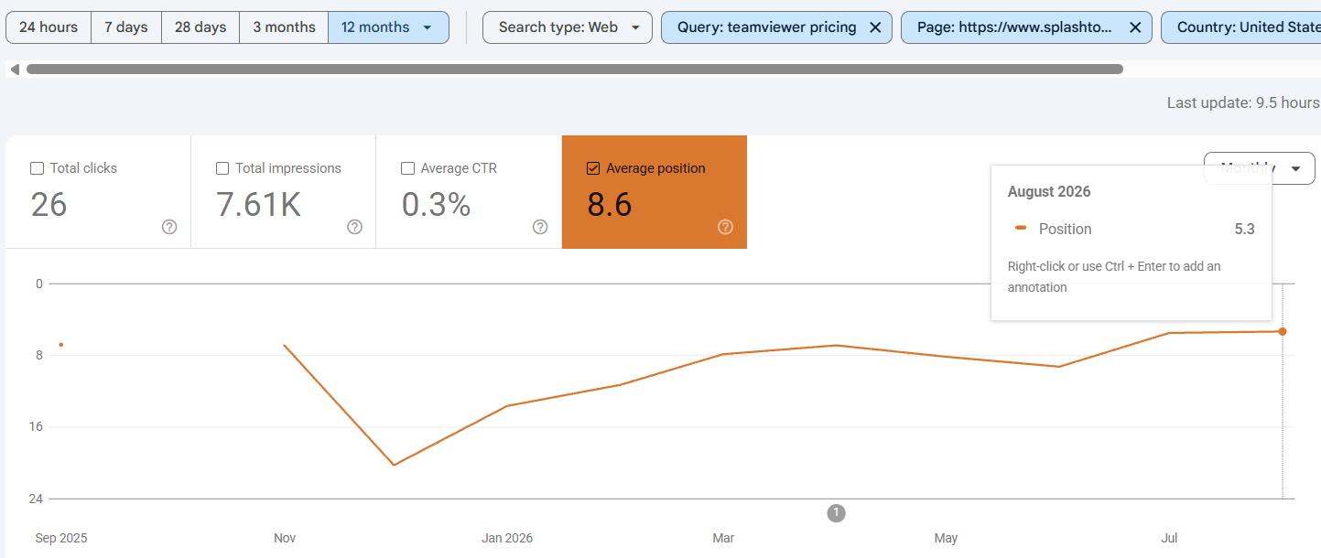
The “TeamViewer Pricing” keyword recovered from ranking fluctuations and reached #5.3 in August, strengthening Splashtop’s position in a key competitor-focused search.

- “AnyDesk Pricing” Secures a Top 5 Ranking
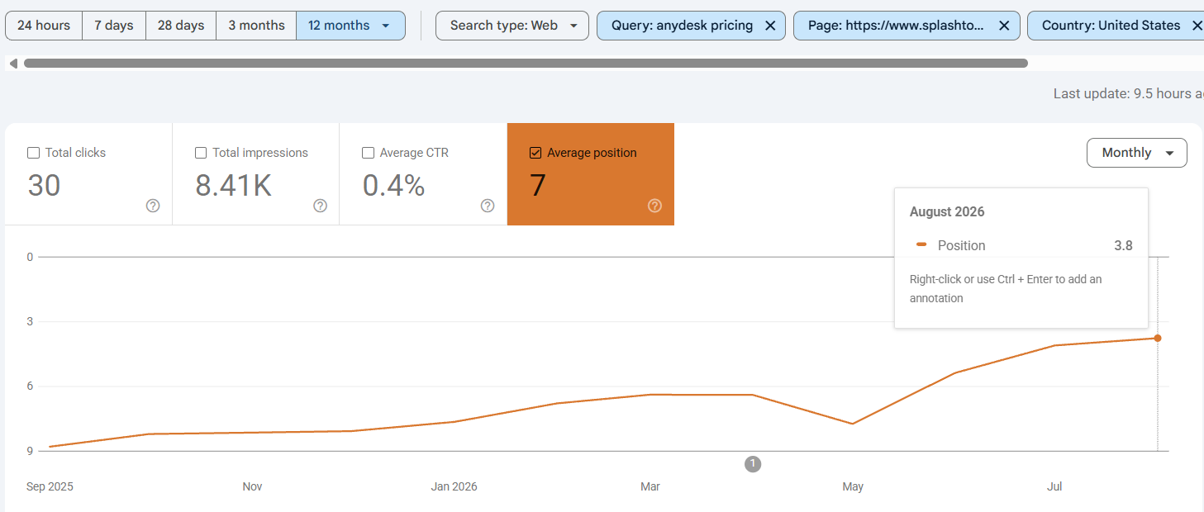
The “AnyDesk Pricing” keyword strengthened from a lower first-page position to #3.8 in August, establishing a strong Top 5 position and improving visibility for a high-intent pricing search.

LLM Highlights:
- Strongest AI Visibility Across Key Categories

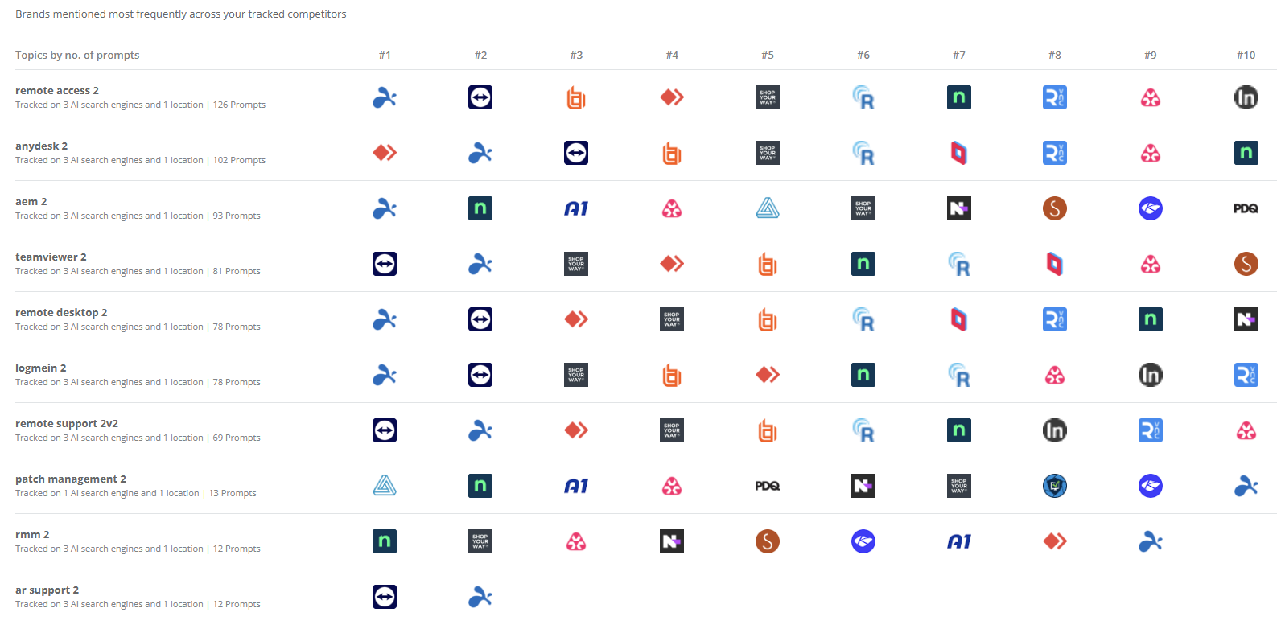

Splashtop is the only player represented across all 10 priority topics, with Top 2 rankings across 8 of the 10, demonstrating the broadest and strongest AI visibility across the tracked categories.

- #1 AI Mention Share in Remote Access
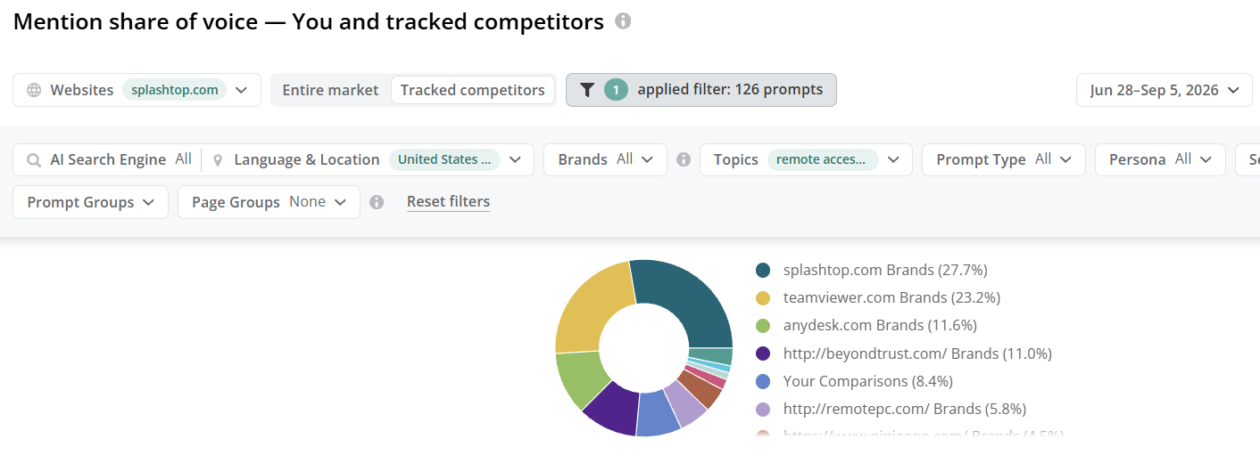

Splashtop secured the highest share of AI brand mentions at 27.7%, maintaining a clear lead over TeamViewer and other tracked competitors across the monitored remote access prompts.

- Dominant AI Citation Share in Remote Support

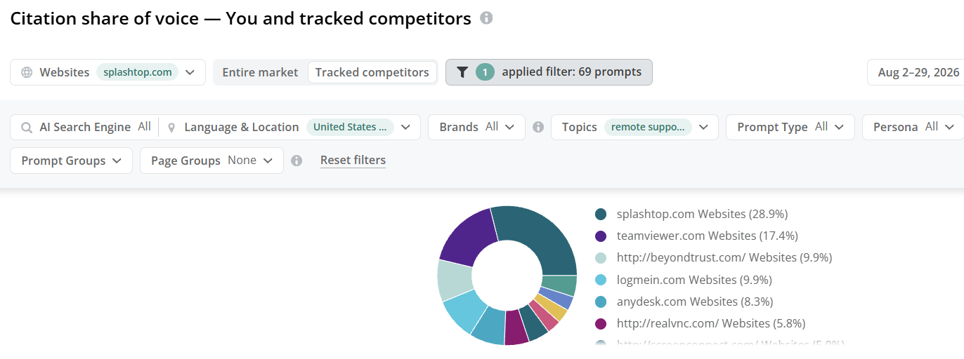

Splashtop captured the highest AI citation share in the Remote Support category at 28.9%, leading TeamViewer by more than 11 percentage points and strengthening its visibility across AI-generated responses.

- Leading AI Citation Presence in AEM

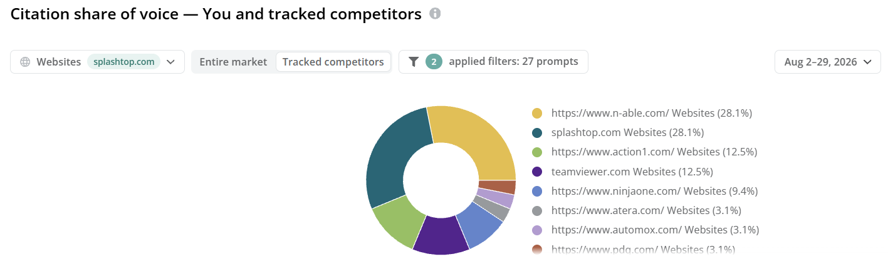

Splashtop secured a 28.1% AI citation share in the AEM category, tying for the highest share among tracked competitors and establishing a leading position in AI-generated AEM responses.

